7. Write a C program for the following ciphertext was generated using a simple substitution algorithm.
53‡‡†305))6*;4826)4‡.)4‡);806*;48†8¶60))85;;]8*;:‡*8†83
(88)5*†;46(;88*96*?;8)*‡(;485);5*†2:*‡(;4956*2(5*—4)8¶8*
;4069285);)6†8)4‡‡;1(‡9;48081;8:8‡1;48†85;4)485†528806*81 (‡9;48;(88;4(‡?34;48)4‡;161;:188;‡?;
PROGRAM
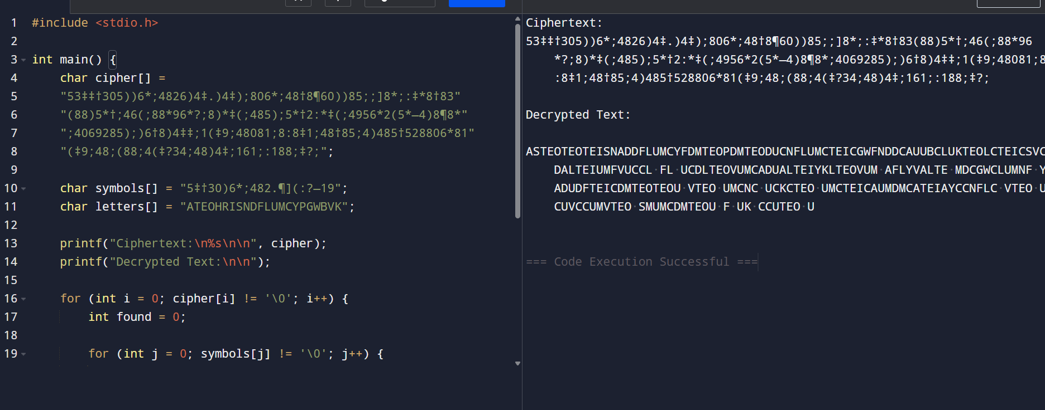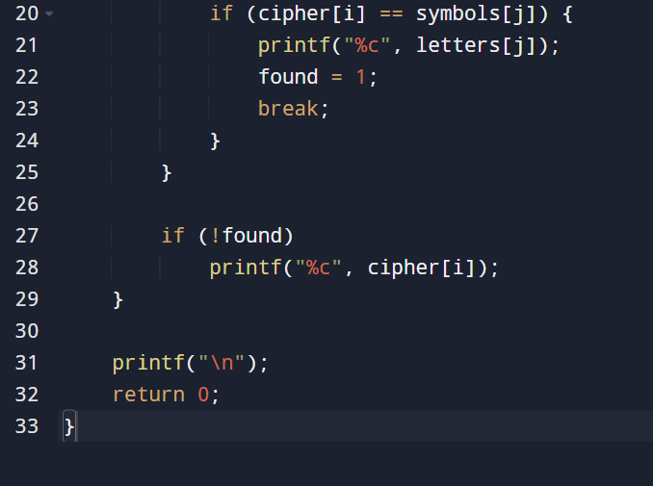
8. Write a C program for monoalphabetic cipher is that both sender and receiver must commit the
permuted cipher sequence to memory. A common technique for avoiding this is to use a keyword from
which the cipher sequence can be generated.
For example, using the keyword CIPHER, write out the keyword followed by unused letters in normal
order and match this against the plaintext letters:
plain: a b c d e f g h i j k l m n o p q r s t u v w x y z
cipher: C I P H E R A B D F G J K L M N O Q S T U V W X Y Z
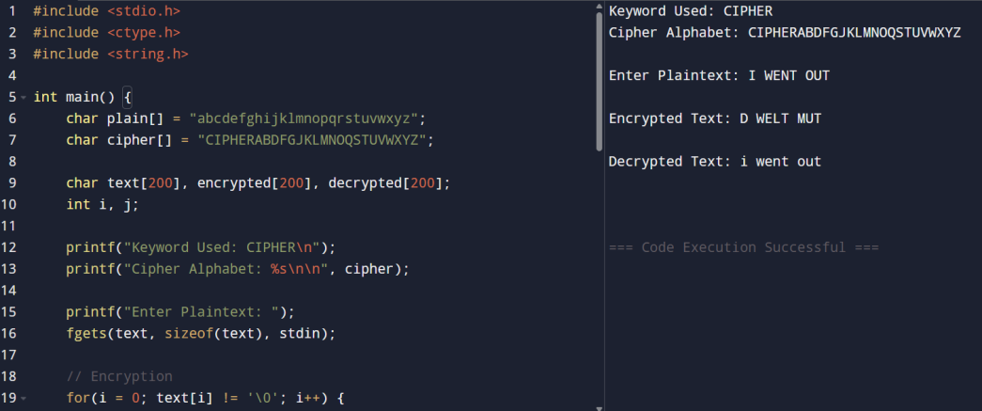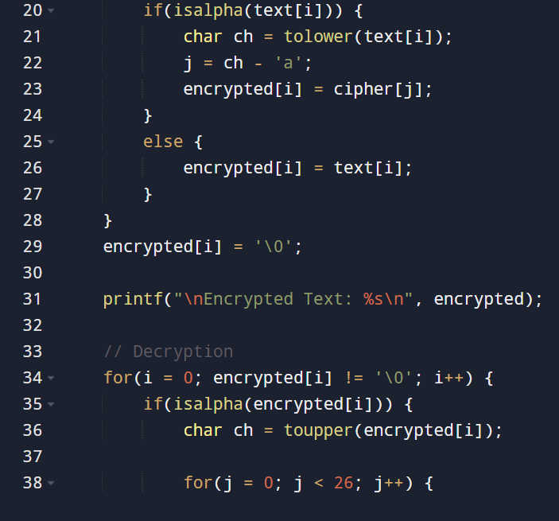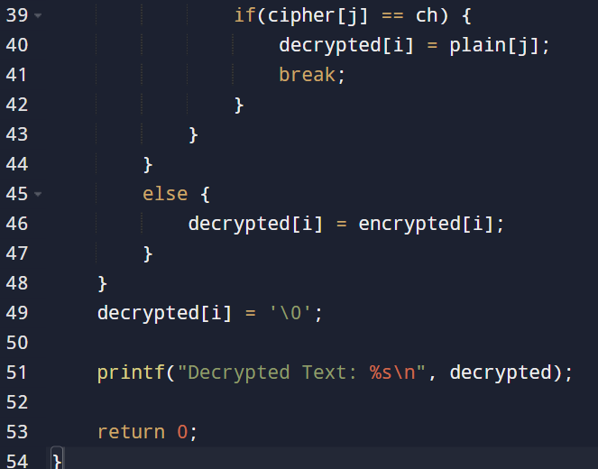

9. Write a C program for PT-109 American patrol boat, under the command of Lieutenant John F.
Kennedy, was sunk by a Japanese destroyer, a message was received at an Australian wireless station in
Playfair code:
KXJEY UREBE ZWEHE WRYTU HEYFS
KREHE GOYFI WTTTU OLKSY CAJPO
BOTEI ZONTX BYBNT GONEY CUZWR
GDSON SXBOU YWRHE BAAHY USEDQ
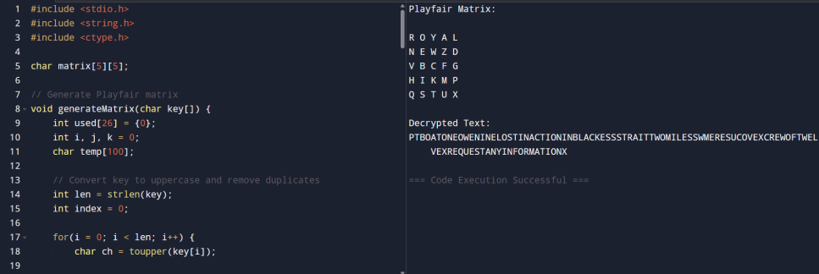
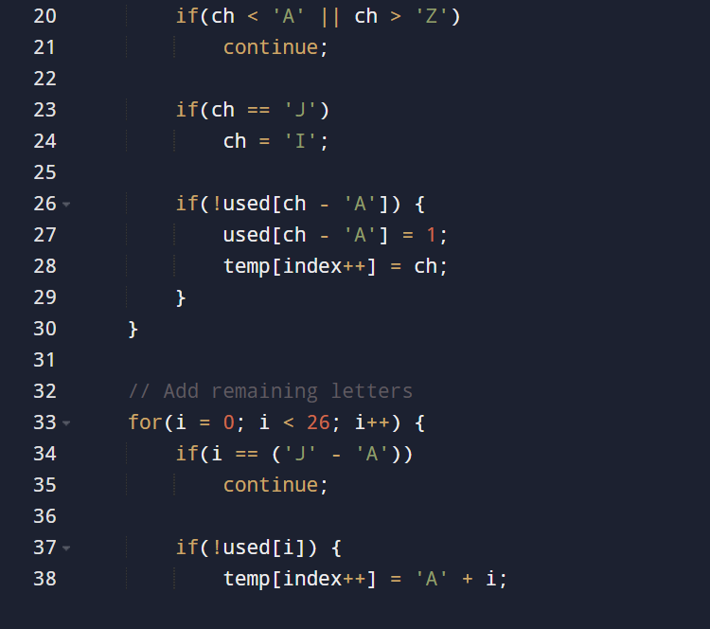
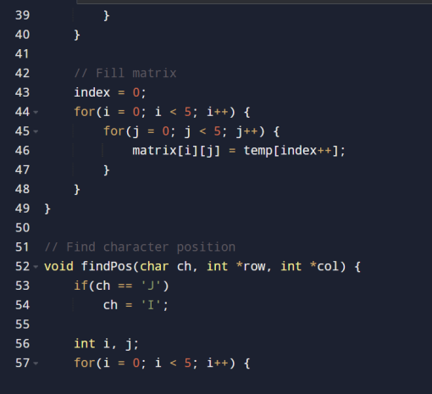

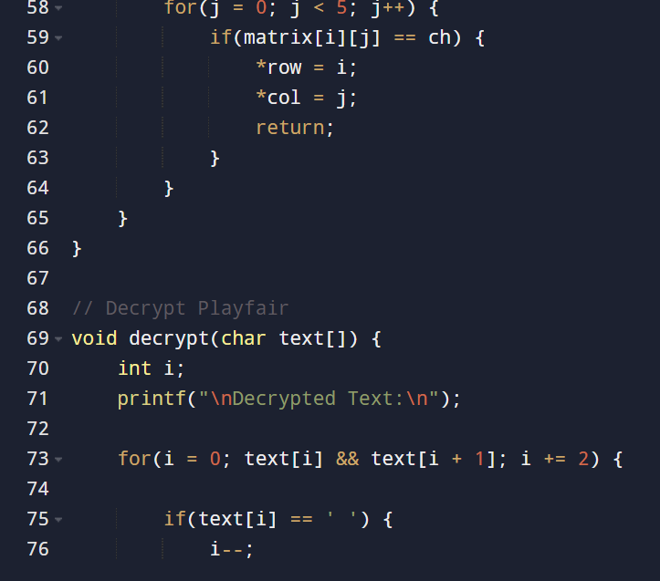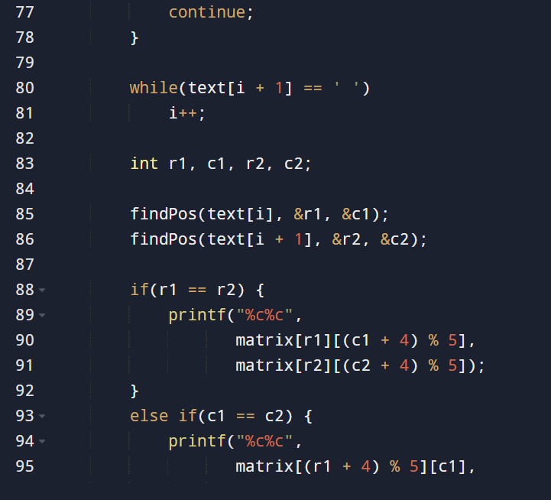

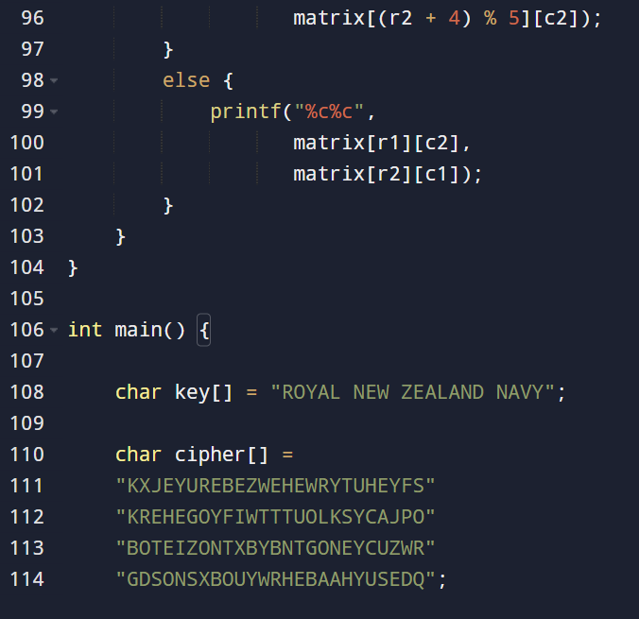
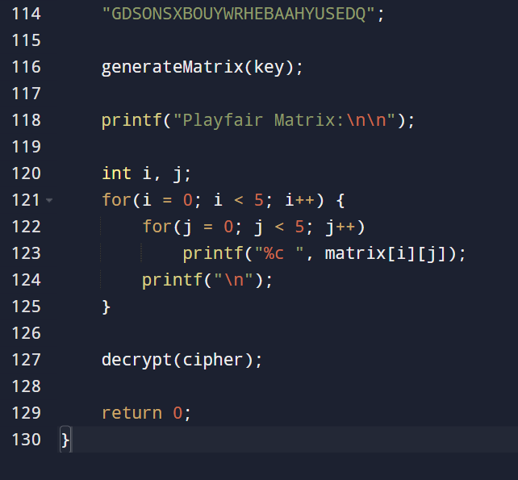
10. Write a C program for Playfair matrix:
M F H I/J K
U N O P Q
Z V W X Y
E L A R G
D S T B C
Encrypt this message: Must see you over Cadogan West. Coming at once.
